Terraform_Challenge-03
Terraform Microservice Challenge — Complete Steps
Final architecture
INTERNET
|
| HTTP :80
v
+---------------------+
| Application Load |
| Balancer |
| Port 80 |
+----------+----------+
|
| HTTP :80
v
+---------------------+
| EC2 Ubuntu |
| |
Your IP ----------> SSH :22 |
| |
| Docker |
| └── Nginx :80 |
+----------+----------+
|
| docker pull
v
+---------------------+
| Docker Hub |
| terraform-microservice|
+---------------------+
The critical security rule is:
Internet ─────X────> EC2:80

Internet ──────────> ALB:80 ─────> EC2:80

Your IP ───────────> EC2:22

PHASE 1 — Prerequisites
Step 1 — Check Terraform
Open Git Bash:
terraform version
Expected:
Terraform v1.x.x

Step 2 — Check Docker
docker --version
Then:
docker info
Make sure Docker Desktop is running.

Step 3 — Check AWS CLI
aws --version

Step 4 — Check Git
git –version
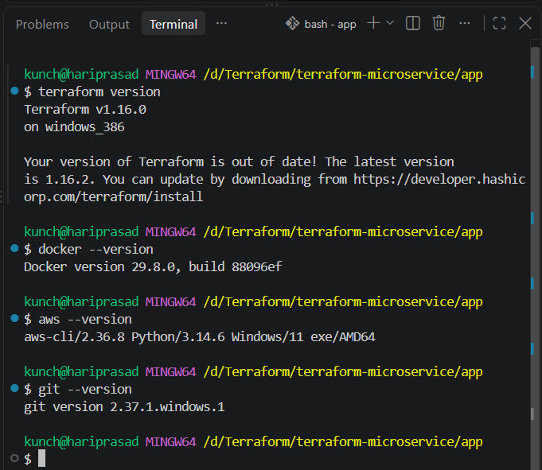

PHASE 2 — Docker Hub
Step 5 — Create Docker Hub repository
Go to Docker Hub and create:
terraform-microservice
For this exercise, make it Public.
Your final image name will be:
YOUR_USERNAME/terraform-microservice:latest
Example:
venu123/terraform-microservice:latest
Replace venu123 with your actual Docker Hub username.
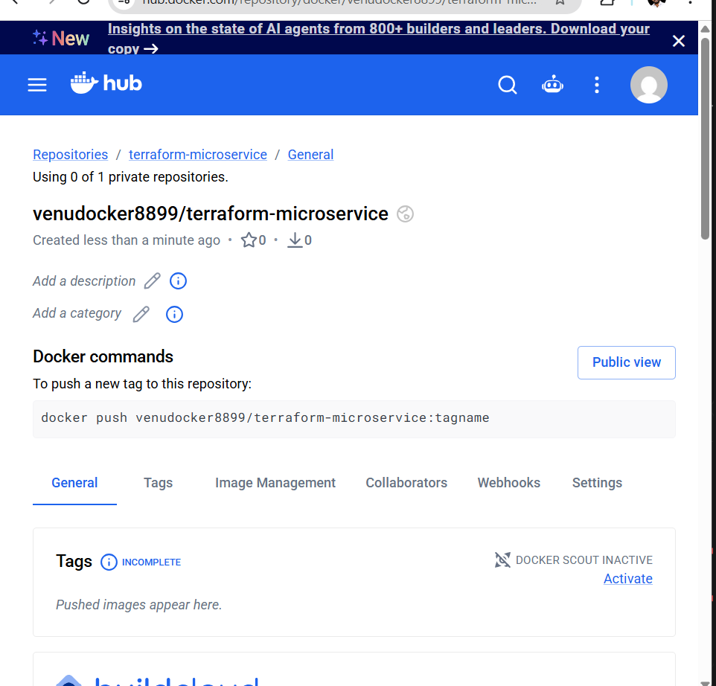

Step 6 — Login to Docker Hub
docker login
Successful result:
Login Succeeded
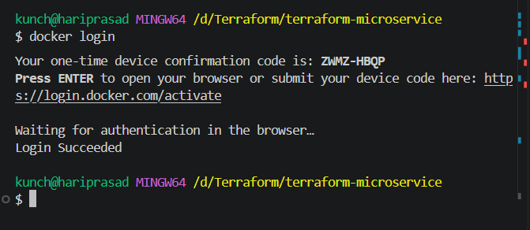

PHASE 3 — Project Creation
Step 7 — Create project
cd /d/Terraform
Create:
mkdir terraform-microservice
cd terraform-microservice
Create folders:
mkdir app
mkdir terraform
mkdir scripts
Final initial structure:
terraform-microservice/
│
├── app/
├── terraform/
└── scripts/
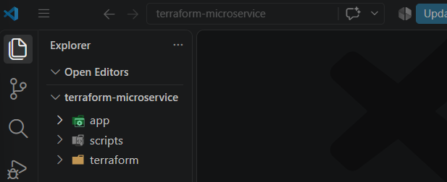

PHASE 4 — Application
Step 8 — Create index.html
Create:
app/index.html
Content:
<!DOCTYPE html>
<html lang="en">
<head>
<meta charset="UTF-8">
<meta name="viewport" content="width=device-width, initial-scale=1.0">
<title>Terraform Microservice</title>
</head>

<body>

<h1>Hello from Terraform Microservice!</h1>

<p>
This application is running inside a Docker container
on an AWS EC2 instance.
</p>

<p>
Terraform + Docker Hub + AWS + Application Load Balancer
</p>

</body>
</html>

PHASE 5 — Dockerfile
Step 9 — Create Dockerfile
Create:
app/Dockerfile
Use:
FROM nginx:alpine

COPY index.html /usr/share/nginx/html/index.html

EXPOSE 80

CMD ["nginx", "-g", "daemon off;"]

PHASE 6 — Build Docker Image
Step 10 — Build locally
cd /d/Terraform/terraform-microservice/app
Build:
docker build -t terraform-microservice:latest .
Check:
docker images
You should see:
terraform-microservice
latest
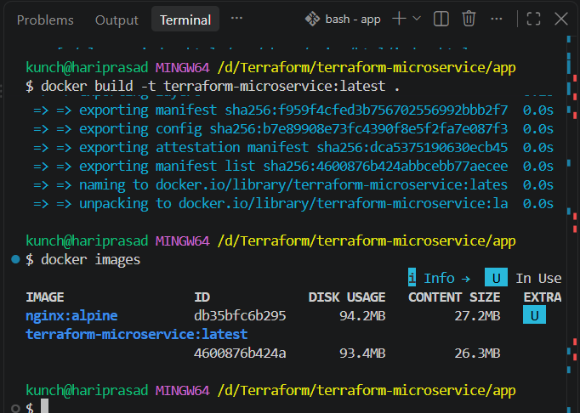

PHASE 7 — Test Docker Locally
Step 11 — Run container
docker run -d \
--name terraform-microservice \
-p 8080:80 \
terraform-microservice:latest
Check:
docker ps
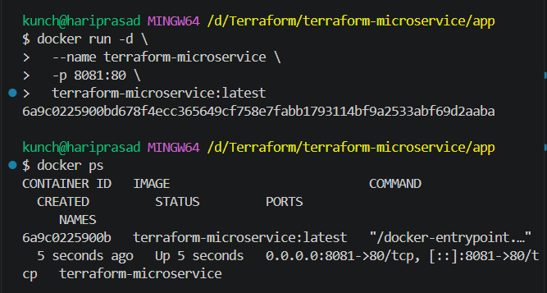
Open:
http://localhost:8081
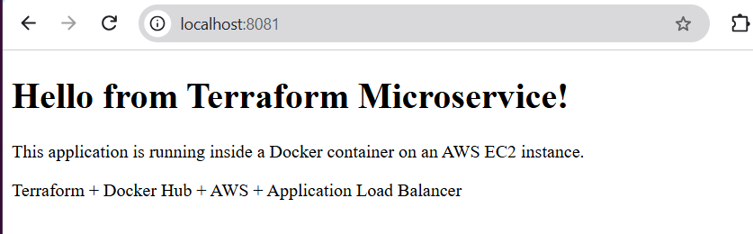
You should see:
Hello from Terraform Microservice!
You can also test:
curl http://localhost:8081
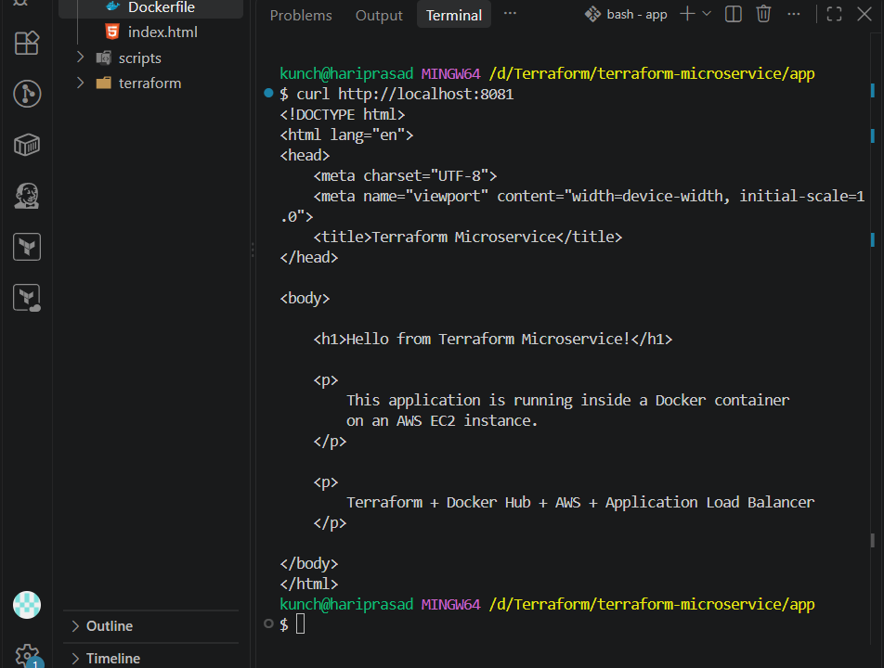

Step 12 — Remove test container
docker stop terraform-microservice
Then:
docker rm terraform-microservice
Don't remove the image.
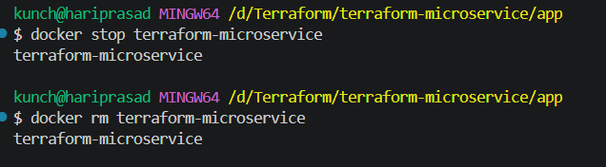

PHASE 8 — Push Image to Docker Hub
Step 13 — Tag image
Replace YOUR_USERNAME.
docker tag terraform-microservice:latest \
YOUR_USERNAME/terraform-microservice:latest
Example:
docker tag terraform-microservice:latest \
venu123/terraform-microservice:latest

Step 14 — Push image
docker push YOUR_USERNAME/terraform-microservice:latest
Example:
docker push venu123/terraform-microservice:latest
Verify the image appears in Docker Hub.
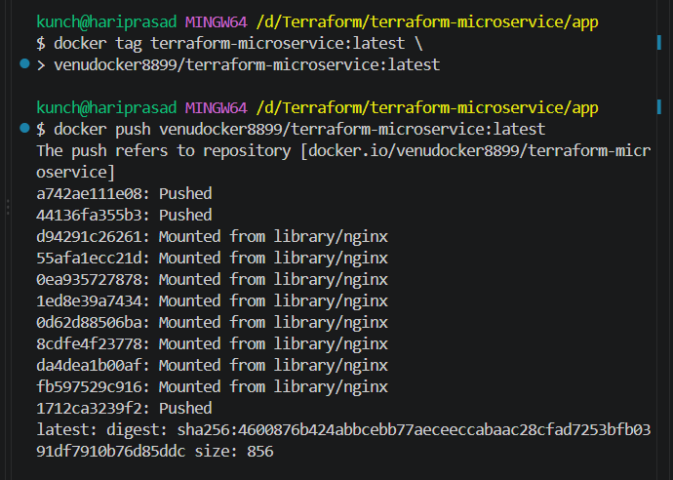

PHASE 9 — AWS Configuration
Step 15 — Configure AWS CLI
aws configure
Provide:
AWS Access Key ID
AWS Secret Access Key
Default region
Output format
For example:
ap-south-2

Step 16 — Verify AWS credentials
aws sts get-caller-identity
You should receive your AWS account information.
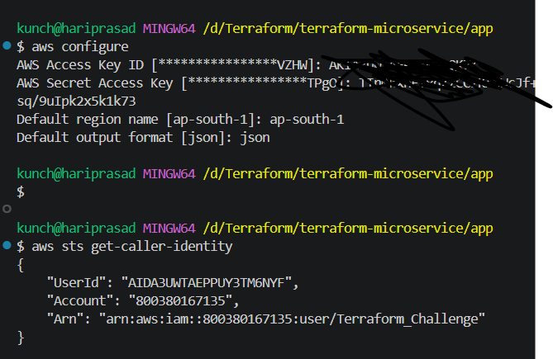

PHASE 10 — Find SSH IP
Step 17 — Get your public IP
Run:
curl -4 ifconfig.me
Suppose it returns:
49.x.x.x
We'll use:
49.x.x.x/32
/32 means only that specific IP.
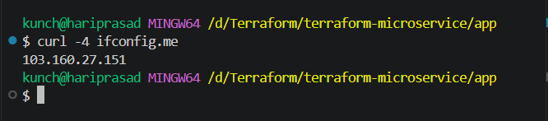

PHASE 11 — SSH Key
Step 18 — Create SSH key
Go to project root:
cd /d/Terraform/terraform-microservice
Create key:
ssh-keygen -t rsa -b 4096 -f terraform-microservice-key
You'll get:
terraform-microservice-key
terraform-microservice-key.pub
Do not upload or commit the private key.
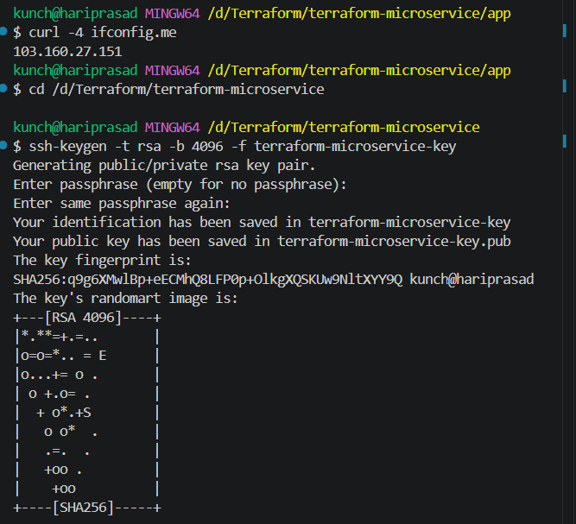

PHASE 12 — Terraform Files
Step 19 — Create Terraform files
Inside:
terraform/
create:
terraform/
│
├── versions.tf
├── provider.tf
├── variables.tf
├── locals.tf
├── data.tf
├── network.tf
├── security-groups.tf
├── iam.tf
├── keypair.tf
├── docker.tf
├── ec2.tf
├── alb.tf
├── outputs.tf
└── terraform.tfvars

PHASE 13 — Terraform Provider
Step 20 — versions.tf
terraform {
required_version = ">= 1.5.0"

required_providers {
aws = {
source = "hashicorp/aws"
version = "~> 6.0"
}

docker = {
source = "kreuzwerker/docker"
version = "~> 4.6"
}
}
}

PHASE 14 — AWS Provider
Step 21 — provider.tf
provider "aws" {
region = var.aws_region
}

provider "docker" {
host = "npipe:////./pipe/docker_engine"

registry_auth {
address = "https://index.docker.io/v1/"
username = var.dockerhub_username
password = var.dockerhub_token
}
}
Important
On Windows + Docker Desktop, this Docker host is commonly used:
npipe:////./pipe/docker_engine
If your Docker provider has connection issues, we'll troubleshoot that separately.

PHASE 15 — Variables
Step 22 — variables.tf
variable "aws_region" {
description = "AWS region"
type = string
}

variable "project_name" {
description = "Project name"
type = string
}

variable "vpc_cidr" {
description = "VPC CIDR"
type = string
}

variable "public_subnet_1_cidr" {
description = "First public subnet CIDR"
type = string
}

variable "public_subnet_2_cidr" {
description = "Second public subnet CIDR"
type = string
}

variable "instance_type" {
description = "EC2 instance type"
type = string
}

variable "dockerhub_username" {
description = "Docker Hub username"
type = string
}

variable "dockerhub_token" {
description = "Docker Hub access token"
type = string
sensitive = true
}

variable "docker_image" {
description = "Docker Hub image"
type = string
}

variable "ssh_allowed_cidr" {
description = "CIDR allowed for SSH"
type = string
}

variable "key_name" {
description = "AWS EC2 key pair name"
type = string
}

variable "public_key_path" {
description = "Path to public SSH key"
type = string
}

PHASE 16 — Terraform Locals
Step 23 — locals.tf
locals {
common_tags = {
Project = var.project_name
Environment = "dev"
ManagedBy = "Terraform"
}

container_name = "terraform-microservice"
}

PHASE 17 — Data Sources
Step 24 — data.tf
We'll use the latest Ubuntu AMI available through AWS's public SSM parameter.
data "aws_ssm_parameter" "ubuntu_ami" {
name = "/aws/service/canonical/ubuntu/server/24.04/stable/current/amd64/hvm/ebs-gp3/ami-id"
}
This avoids hardcoding an AMI ID.

PHASE 18 — VPC
Step 25 — network.tf
resource "aws_vpc" "main" {
cidr_block = var.vpc_cidr
enable_dns_support = true
enable_dns_hostnames = true

tags = merge(
local.common_tags,
{
Name = "${var.project_name}-vpc"
}
)
}

PHASE 19 — Internet Gateway
Add to network.tf:
resource "aws_internet_gateway" "main" {
vpc_id = aws_vpc.main.id

tags = merge(
local.common_tags,
{
Name = "${var.project_name}-igw"
}
)
}

PHASE 20 — Availability Zones
Add:
data "aws_availability_zones" "available" {
state = "available"
}

PHASE 21 — Subnet 1
Add:
resource "aws_subnet" "public_1" {
vpc_id = aws_vpc.main.id
cidr_block = var.public_subnet_1_cidr
availability_zone = data.aws_availability_zones.available.names[0]
map_public_ip_on_launch = true

tags = merge(
local.common_tags,
{
Name = "${var.project_name}-public-subnet-1"
}
)
}

PHASE 22 — Subnet 2
resource "aws_subnet" "public_2" {
vpc_id = aws_vpc.main.id
cidr_block = var.public_subnet_2_cidr
availability_zone = data.aws_availability_zones.available.names[1]
map_public_ip_on_launch = true

tags = merge(
local.common_tags,
{
Name = "${var.project_name}-public-subnet-2"
}
)
}

PHASE 23 — Route Table
Add:
resource "aws_route_table" "public" {
vpc_id = aws_vpc.main.id

route {
cidr_block = "0.0.0.0/0"
gateway_id = aws_internet_gateway.main.id
}

tags = merge(
local.common_tags,
{
Name = "${var.project_name}-public-rt"
}
)
}

PHASE 24 — Route Associations
resource "aws_route_table_association" "public_1" {
subnet_id = aws_subnet.public_1.id
route_table_id = aws_route_table.public.id
}

resource "aws_route_table_association" "public_2" {
subnet_id = aws_subnet.public_2.id
route_table_id = aws_route_table.public.id
}

PHASE 25 — Security Groups
Step 25A — ALB Security Group
Create security-groups.tf:
resource "aws_security_group" "alb" {
name = "${var.project_name}-alb-sg"
description = "Security group for Application Load Balancer"
vpc_id = aws_vpc.main.id

ingress {
description = "HTTP from internet"
from_port = 80
to_port = 80
protocol = "tcp"
cidr_blocks = ["0.0.0.0/0"]
}

egress {
description = "Allow outbound traffic"
from_port = 0
to_port = 0
protocol = "-1"
cidr_blocks = ["0.0.0.0/0"]
}

tags = merge(
local.common_tags,
{
Name = "${var.project_name}-alb-sg"
}
)
}

PHASE 26 — EC2 Security Group
Add:
resource "aws_security_group" "ec2" {
name = "${var.project_name}-ec2-sg"
description = "Security group for EC2 instance"
vpc_id = aws_vpc.main.id

ingress {
description = "SSH from trusted IP"
from_port = 22
to_port = 22
protocol = "tcp"
cidr_blocks = [var.ssh_allowed_cidr]
}

ingress {
description = "HTTP from ALB only"
from_port = 80
to_port = 80
protocol = "tcp"
security_groups = [aws_security_group.alb.id]
}

egress {
description = "Allow outbound traffic"
from_port = 0
to_port = 0
protocol = "-1"
cidr_blocks = ["0.0.0.0/0"]
}

tags = merge(
local.common_tags,
{
Name = "${var.project_name}-ec2-sg"
}
)
}
This is the most important security configuration.
EC2 SG

22 ---> YOUR IP only
80 ---> ALB SG only

PHASE 27 — SSH Key Pair
Step 27 — keypair.tf
resource "aws_key_pair" "main" {
key_name = var.key_name
public_key = file(var.public_key_path)

tags = merge(
local.common_tags,
{
Name = var.key_name
}
)
}

PHASE 28 — IAM
Because we're using Docker Hub, EC2 doesn't need ECR permissions.
But we can create an EC2 IAM role for basic AWS integration if required.
For this challenge, we can keep IAM minimal.
Create iam.tf:
resource "aws_iam_role" "ec2" {
name = "${var.project_name}-ec2-role"

assume_role_policy = jsonencode({
Version = "2012-10-17"

Statement = [
{
Effect = "Allow"

Principal = {
Service = "ec2.amazonaws.com"
}

Action = "sts:AssumeRole"
}
]
})

tags = local.common_tags
}
Instance profile:
resource "aws_iam_instance_profile" "ec2" {
name = "${var.project_name}-ec2-profile"
role = aws_iam_role.ec2.name
}
No ECR policy is required.

PHASE 29 — Docker Hub Authentication
Important security point
We don't want to put a Docker Hub password directly inside:
user-data
We'll use a Docker Hub access token.
For this challenge, because the repository is public, EC2 doesn't actually need authentication to pull the image.
However, Terraform's Docker provider may need credentials if we want Terraform to manage/push the image.
So:
Terraform
|
Docker Provider
|
Docker Hub
uses the Docker Hub token.
EC2:
EC2
|
docker pull
|
Docker Hub public repository
doesn't need the token.

PHASE 30 — Terraform Docker Image
Create docker.tf.
The exact Docker provider implementation will depend on how we want to satisfy the challenge's "Terraform pushes the local image" requirement.
The important logical sequence is:
Local Docker Image
↓
Terraform Docker Provider
↓
Docker Hub
We'll use the provider's Docker image/registry resources rather than hardcoding a docker push shell command.

PHASE 31 — EC2 User Data
Create:
scripts/user-data.sh
Example:
#!/bin/bash

set -e

apt-get update -y

apt-get install -y docker.io

systemctl enable docker
systemctl start docker

usermod -aG docker ubuntu

docker pull ${docker_image}

docker run -d \
--name terraform-microservice \
--restart unless-stopped \
-p 80:80 \
${docker_image}
Terraform will substitute the image name into the script.

PHASE 32 — EC2 Resource
Create ec2.tf.
resource "aws_instance" "app" {
ami = data.aws_ssm_parameter.ubuntu_ami.value
instance_type = var.instance_type

subnet_id = aws_subnet.public_1.id

vpc_security_group_ids = [
aws_security_group.ec2.id
]

key_name = aws_key_pair.main.key_name

iam_instance_profile = aws_iam_instance_profile.ec2.name

user_data = templatefile(
"${path.module}/../scripts/user-data.sh",
{
docker_image = var.docker_image
}
)

tags = merge(
local.common_tags,
{
Name = "${var.project_name}-ec2"
}
)
}
This creates one EC2 instance only.

PHASE 33 — Application Load Balancer
Create alb.tf.
ALB
resource "aws_lb" "main" {
name = "${var.project_name}-alb"
internal = false
load_balancer_type = "application"

security_groups = [
aws_security_group.alb.id
]

subnets = [
aws_subnet.public_1.id,
aws_subnet.public_2.id
]

tags = local.common_tags
}

PHASE 34 — Target Group
Add:
resource "aws_lb_target_group" "app" {
name = "${var.project_name}-tg"
port = 80
protocol = "HTTP"
vpc_id = aws_vpc.main.id

health_check {
enabled = true
path = "/"
protocol = "HTTP"
port = "traffic-port"
healthy_threshold = 2
unhealthy_threshold = 2
timeout = 5
interval = 30
matcher = "200"
}

tags = local.common_tags
}

PHASE 35 — Attach EC2
Add:
resource "aws_lb_target_group_attachment" "app" {
target_group_arn = aws_lb_target_group.app.arn
target_id = aws_instance.app.id
port = 80
}

PHASE 36 — ALB Listener
Add:
resource "aws_lb_listener" "http" {
load_balancer_arn = aws_lb.main.arn
port = 80
protocol = "HTTP"

default_action {
type = "forward"
target_group_arn = aws_lb_target_group.app.arn
}
}
Final flow:
ALB:80
|
v
Target Group
|
v
EC2:80
|
v
Docker:80
|
v
Nginx

PHASE 37 — Outputs
Create outputs.tf:
output "vpc_id" {
value = aws_vpc.main.id
}

output "ec2_public_ip" {
value = aws_instance.app.public_ip
}

output "ec2_private_ip" {
value = aws_instance.app.private_ip
}

output "alb_dns_name" {
value = aws_lb.main.dns_name
}

output "docker_image" {
value = var.docker_image
}

PHASE 38 — Terraform Variables
Create terraform.tfvars.
Example:
aws_region = "ap-south-2"

project_name = "terraform-microservice"

vpc_cidr = "10.0.0.0/16"

public_subnet_1_cidr = "10.0.1.0/24"

public_subnet_2_cidr = "10.0.2.0/24"

instance_type = "t3.micro"

dockerhub_username = "YOUR_DOCKERHUB_USERNAME"

dockerhub_token = "YOUR_DOCKERHUB_ACCESS_TOKEN"

docker_image = "YOUR_DOCKERHUB_USERNAME/terraform-microservice:latest"

ssh_allowed_cidr = "YOUR_PUBLIC_IP/32"

key_name = "terraform-microservice-key"

public_key_path = "../terraform-microservice-key.pub"
Replace:
YOUR_DOCKERHUB_USERNAME
YOUR_DOCKERHUB_ACCESS_TOKEN
YOUR_PUBLIC_IP

⚠️ Important .gitignore
At project root create:
.gitignore
Use:
.terraform/
*.tfstate
*.tfstate.*
*.tfvars
*.pem
terraform-microservice-key
terraform-microservice-key.pub
crash.log
Why?
Because terraform.tfvars contains your Docker Hub token.
The private key must never go into Git.

PHASE 39 — Terraform Init
Now:
cd /d/Terraform/terraform-microservice/terraform
Run:
terraform init
Expected:
Initializing provider plugins...
You should see AWS and Docker providers being installed.
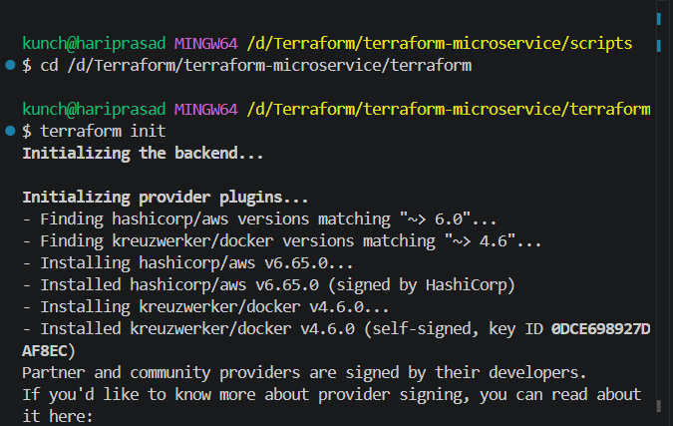

PHASE 40 — Format
terraform fmt -recursive

PHASE 41 — Validate
terraform validate
Expected:
Success! The configuration is valid.
If it fails, stop here and fix it before planning.
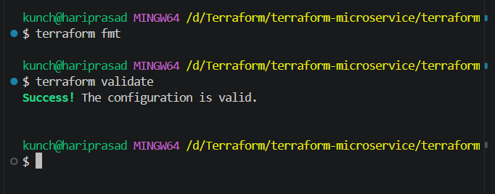

PHASE 42 — Plan
Run:
terraform plan
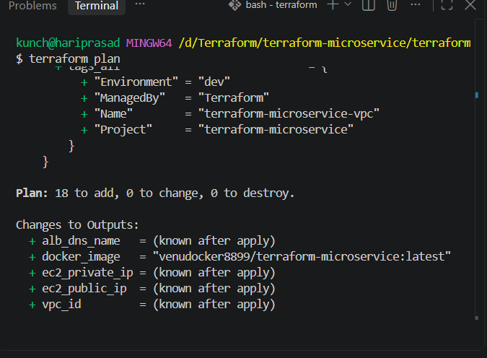
Check carefully.
You should see resources for:
VPC
Internet Gateway
2 Subnets
Route Table
Route Associations
2 Security Groups
Key Pair
IAM Role
IAM Instance Profile
EC2
ALB
Target Group
ALB Listener
Target Attachment
Docker image/registry workflow
There should be:
EC2 = 1
ALB = 1

PHASE 43 — Apply
Run:
terraform apply
Terraform shows the plan.
Confirm:
yes
Then wait.
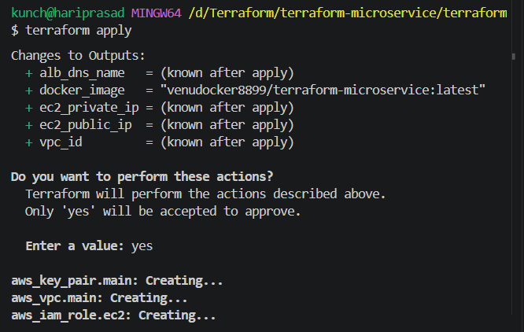
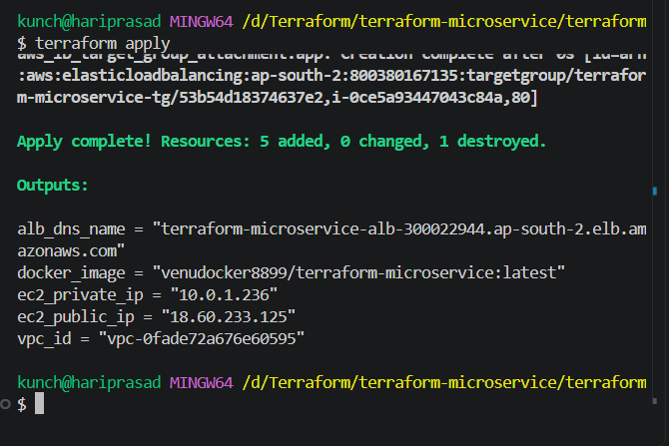

PHASE 44 — Verify Terraform
Run:
terraform state list
You should see resources similar to:
aws_vpc.main
aws_internet_gateway.main
aws_subnet.public_1
aws_subnet.public_2
aws_route_table.public
aws_route_table_association.public_1
aws_route_table_association.public_2
aws_security_group.alb
aws_security_group.ec2
aws_key_pair.main
aws_iam_role.ec2
aws_iam_instance_profile.ec2
aws_instance.app
aws_lb.main
aws_lb_target_group.app
aws_lb_target_group_attachment.app
aws_lb_listener.http
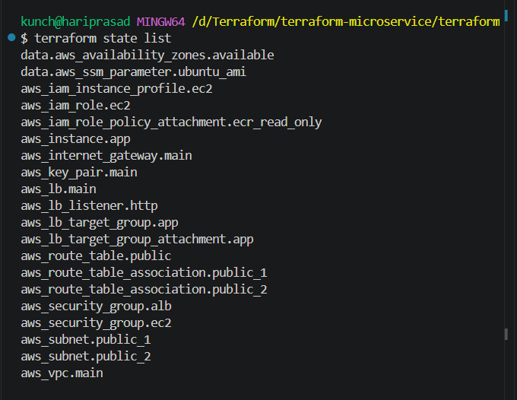

PHASE 45 — Get Outputs
terraform output
You'll get:
alb_dns_name
ec2_public_ip
ec2_private_ip
vpc_id
docker_image
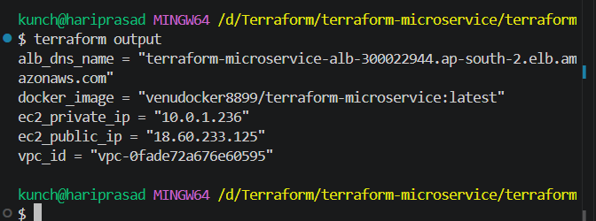

PHASE 46 — Test ALB
Copy:
alb_dns_name
Open:
http:// terraform-microservice-alb-300022944.ap-south-2.elb.amazonaws.com
Expected:
Hello from Terraform Microservice!
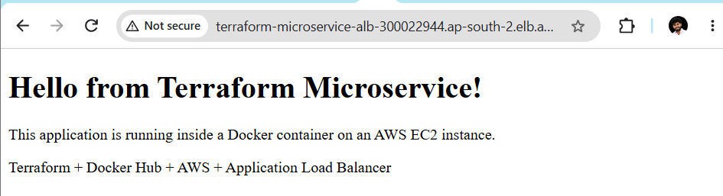

PHASE 47 — SSH to EC2
Use:
ssh -i ../terraform-microservice-key ubuntu@EC2_PUBLIC_IP
If Windows permissions cause an SSH private-key warning, we'll fix that at that point.
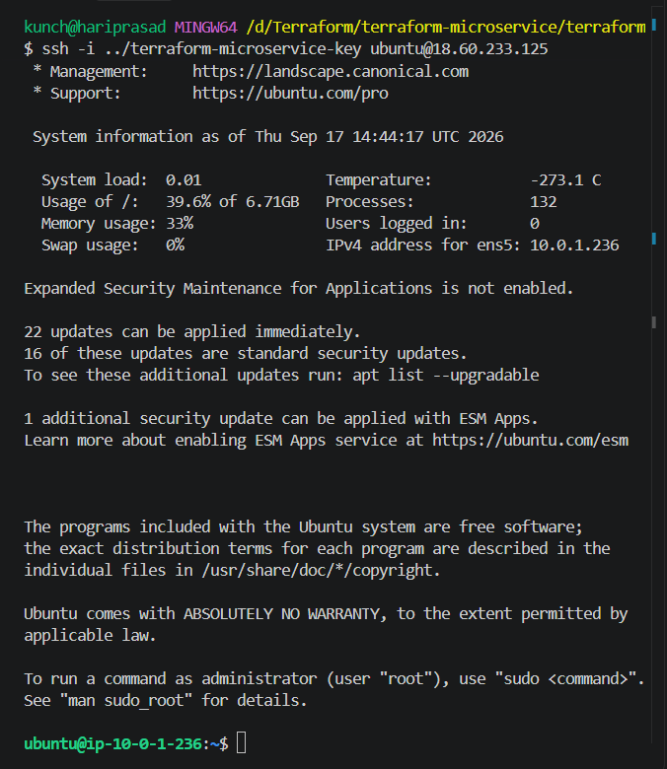

PHASE 48 — Verify Docker
On EC2:
docker --version
Then:
docker ps
Expected:
terraform-microservice
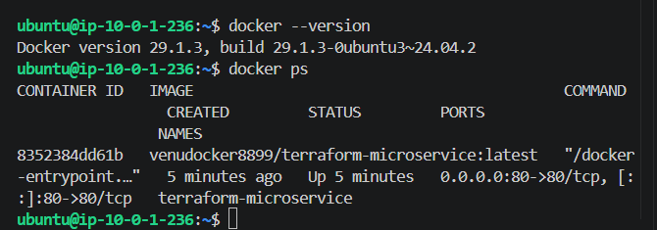

PHASE 49 — Verify Image
Run:
docker images
You should see:
YOUR_USERNAME/terraform-microservice
Latest
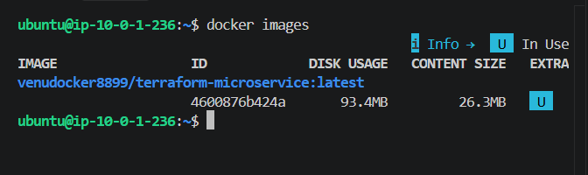

PHASE 50 — Test container directly from EC2
On EC2:
curl http://localhost
You should receive your HTML.
This confirms:
Docker
↓
Container
↓
Nginx
↓
HTML
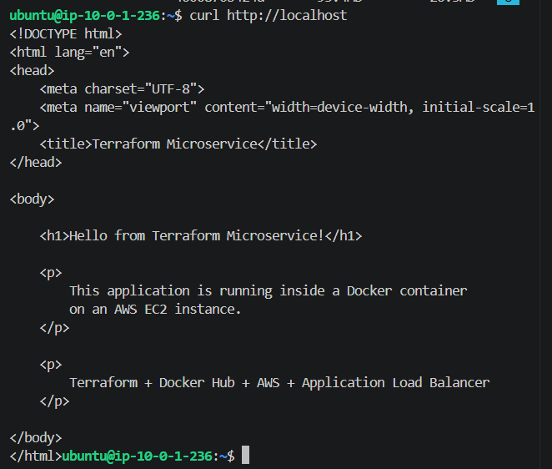

PHASE 51 — Test ALB Health
AWS Console:
EC2
↓
Load Balancers
↓
Your ALB
↓
Target Groups
↓
Targets
Target should become:
healthy
If it's unhealthy, don't continue. We'll troubleshoot.
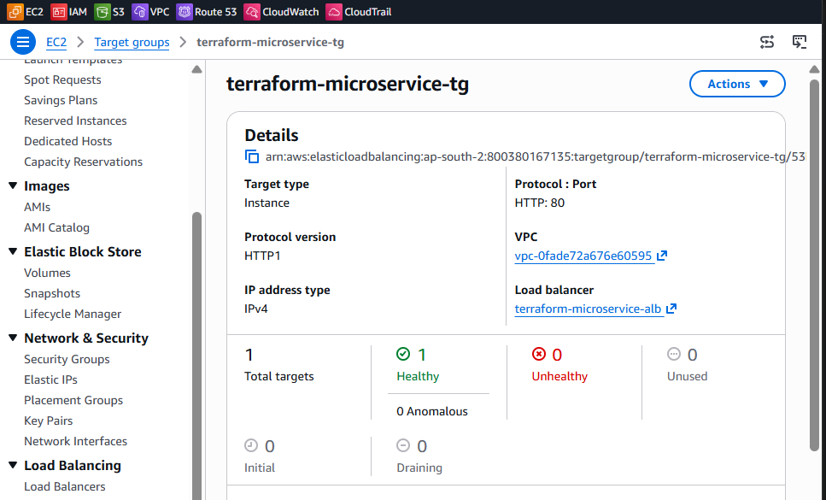

PHASE 52 — Security Test: Direct EC2 HTTP
Take the EC2 public IP:
http://EC2_PUBLIC_IP
It should NOT expose your application.
Why?
Because EC2 security group says:
Port 80
Source = ALB Security Group
not:
0.0.0.0/0
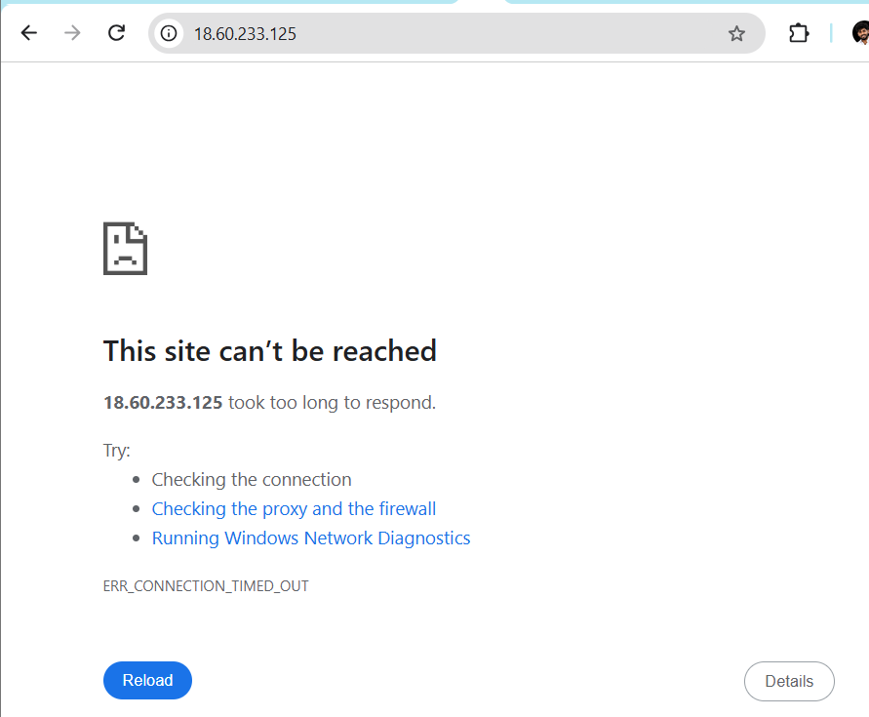

PHASE 53 — Security Test: ALB
Now:
http://ALB-DNS-NAME
Should work:
ALB
↓
EC2
↓
Docker
↓
Nginx
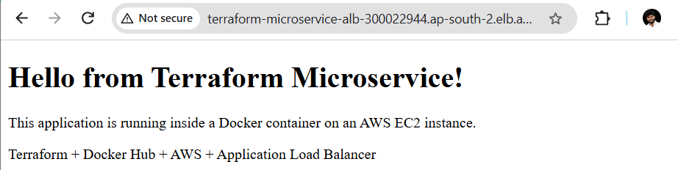

PHASE 54 — SSH Test
From your allowed IP:
ssh -i ../terraform-microservice-key ubuntu@EC2_PUBLIC_IP
Should work.
The security group allows:
YOUR_IP/32 → 22
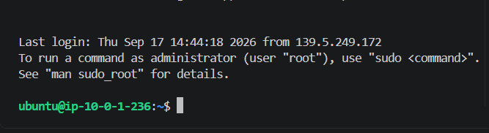

PHASE 55 — Review the architecture
At this point we should have:
INTERNET
|
| :80
v
+---------+
| ALB |
+----+----+
|
| :80
v
+---------+
| EC2 |
+----+----+
|
v
+---------+
| Docker |
| Nginx |
+----+----+
|
v
Static HTML
Docker image source:
Docker Hub
|
| pull
v
EC2
SSH:
Your IP
|
| :22
v
EC2

PHASE 56 — Final Terraform Destroy
Once everything has been tested:
terraform destroy
Review the resources.
Confirm:
yes
Wait until:
Destroy complete!
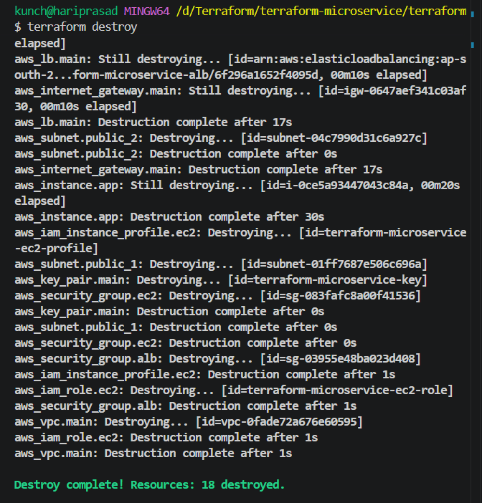

PHASE 57 — Verify Terraform State
Run:
terraform state list
There should be no resources remaining.
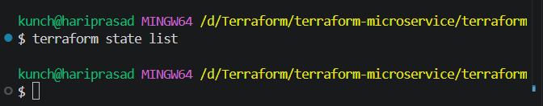

PHASE 58 — Verify AWS Cleanup
Check AWS Console:
EC2
Instance terminated
Load Balancer
Deleted
Target Group
Deleted
VPC
Deleted
Subnets
Deleted
Internet Gateway
Deleted
Security Groups
Deleted
IAM
Role/Profile deleted
The EC2 key pair may also be deleted if Terraform manages it as a resource.
